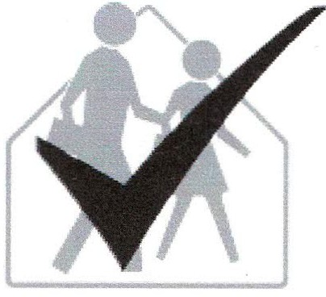
School IPM Tool Kit
Office Staff, Teachers, and Students Checklist
Instructions
Name: 1. Read the information on this sheet.
Room/Area: 2. Check the appropriate box.
School: 3. Write any items needing attention (usually
Date Completed: indicated by a 'No' response) in the places
provided at the end of each section.
Signature: 4. Return completed checklist to the IPM
coordinator; keep a copy for your records.

4. Return completed checklist to the IPM
coordinator; keep a copy for your records.
It is the policy of this school district to manage pest problems in ways that pose the least hazard to human health and the environment. To this end, we have adopted an integrated pest management (IPM) program. IPM combines pest prevention, non-chemical pest control methods, and the appropriate use of pesticides that are the least harmful to human health and the environment. By addressing and correcting the root causes of pest problems, IPM can provide long-term, economical pest control and
minimize the risk of pesticide exposure.
We are asking for your cooperation with our IPM program! The success of IPM depends on the involvement of many individuals. Students, teachers, school staff, administration, and parents are all participants in the IPM program. Together we can help reduce pest problems and pesticide applica­ tions. Do not put pressure on school staff to apply pesticides; there are other effective means of controlling pest problems. You can have a positive impact on our goal to reduce pest problems by completing the following checklist as indicated by your IPM coordinator.
The most important pest management responsibility of students and staff is sanitation. Much of the prevention and reduction of pest infestation depends on whether or not food is left in classrooms, common areas, and lockers. In addition, staff and students can provide important information by reporting the presence of pests.

Yes No
0 0 Only district-approved staff are allowed to apply any pesticide, including wasp sprays and ant cups.
0 0 District policies concerning use of disinfectants, cleaners, and sanitizers are adhered to.
0 0 Clogged or leaking plumbing, lavatories, sinks, water fountains, heating/ventilation systems, or
water coolers are promptly reported and repaired.
0 0 Sink areas are kept clean and dry.
0 0 Trash generated after custodians have left is removed from the classroom by end of day.
0 0 Work areas are neat and organized.
0 0 Leftover or spilled food and beverages are cleaned-up immediately.

Yes No
0 0 Spills on carpets are reported to maintenance and cleaned immediately.
0 0 Empty cans and bottles are rinsed and excess water drained, removed from classrooms, and placed in designated bins.
0 0 Recyclables are stored only in designated receptacles.
0 0 Classrooms and storage areas are organized; not cluttered or congested.
0 0 Cardboard boxes are kept to a minimum.
0 0 The unit ventilator is clean. If liquid has spilled inside, the filter has been replaced.
0 0 All vents, air conditioners, heating units, and unit ventilators are not blocked (nothing placed on unit ventilators).
0 0 All malfunctioning equipment, especially heating, ventilating, air conditioning and plumbing is promptly reported and repaired.
0 0 Windows screens are in good repair.
0 0 Windows without screens are kept closed.
0 0 Exterior doors that could allow pests to enter are kept closed.
0 0 Refrigerators, vending machines, and microwaves are clean and free of spills.
0 0 Sticky traps and bait boxes to monitor or kill pests are tamper-proof and inaccessible to students.
0 0 No pesticides, cleaning products, or other chemicals are stored in classrooms. Any pesticides stored on school property are kept in locked cabinets.
0 0 Open, unsealed food is not stored in desks, file cabinets, or lockers.
0 0 Potted plants are kept to a minimum. Avoid overwatering and check regularly for pests and moldy smells.
0 0 Cracks and crevices in walls, floors, around pipes, under cabinets, etc. are promptly reported and sealed.
0 0 Lockers and desks are emptied and cleaned at least twice per year.
0 0 Sufficient space is provided between coat hooks so that each child's hat and coat do not touch those of another to prevent spreading of head lice.
0 0 Food, food wrappers, and open beverage containers are removed from lockers, desks, and teachers' rooms daily.
0 0 Potential pest food items used in classrooms (e.g., beans, plant seeds, pet food and bedding, decorative corn, gourds) are refrigerated or stored in glass or metal containers with pest-proof lids.
0 0 Food and beverages are allowed only in designated areas that are cleaned daily.
0 0 Materials are stored away from walls and off floors to allow for regular pest inspection.
0 0 Animal wastes from classroom pets or laboratory animals are flushed or placed in sealed containers before disposal.
0 0 Heavy furnishings and equipment (e.g., staff desks, bookcases, filing cabinets) are moved to permit thorough cleaning around and underneath at least annually.
0 0 Furniture that is rarely moved (e.g., staff desks, bookcases, filing cabinets) are of a design that permits complete cleaning under and around the furniture, or ready movement for cleaning purposes.

Action needed: Completed (Date/Initials)

