School IPM Tool Kit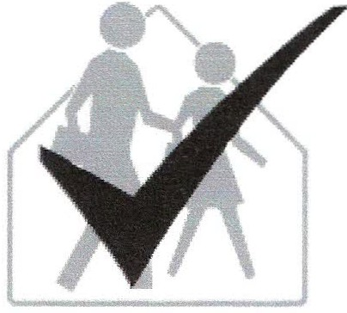
Record Keeping Checklist

Monitoring involves regularly inspecting school buildings and grounds for pests, the damage they cause, and conditions that favor their presence. Monitoring may be done by school staff or a contracted pest management company. Use a standardized method of monitoring for each location; record all observations and keep them in the school's logbook or return them to the IPM coordinator. Keep a record or map showing the location of each trap and bait station on school property.
Accurate record keeping allows a realistic evaluation of the IPM program. Records also help in forecasting when seasonal pests may appear. The IPM coordinator must ensure that monitoring records are up­to-date and accessible and must keep a log of pest management activities, including all pesticide treatments for at least two years. Most schools keep one set of records in an IPM logbook at the school and keep a duplicate set of records in the IPM coordinator’s office. Some schools are required by state regulations to keep all pest monitoring logs, pesticide application records, and pesticide labels and safety data sheets (SDSs), and to make these available upon request for two years.
Inspection of specific areas where pests have been reported should answer these questions:
• How are the pests getting in? Can this access be reduced or eliminated?
• What food or other resource attracted the pests? Can this source be reduced or eliminated?
• Where exactly are the pests living? Can these sites be altered or removed to reduce pest problems?
Traps can help you to monitor and control pests between inspections. Sticky traps are the most common monitoring tools. These glue-covered traps are mostly used to trap crawling insects and small rodents. Mechanical traps can be used to monitor and control rodents. Pheromone traps are valuable tools for monitoring certain pests, particularly stored product pests. Pheromones are the natural scents insects use to communicate with each other. Certain pests are strongly attracted to the traps, providing an extremely effective early warning system.

Daily monitoring: If a rodent or cockroach infestation is detected, the infested area must be inspected and traps serviced daily until infestation is eliminated.
Monthly flashlight inspections of kitchen areas, behind and under appliances, sinks, soda machines, storage facilities, and similar areas may be needed to locate rodents, cockroaches, silverfish, ants, and other pests.
Monthly inspection of athletic fields, turf and ornamental plants may be sufficient. If previous records show a pattern of pest problems, inspections may be adjusted to weekly as needed.
Seasonal inspections are helpful in alerting staff to certain problems. In spring, birds may attempt to nest in building corners or openings and wasps may begin nest building. ln the fall, school buildings may be invaded by species looking for winter sites, including rodents, cluster flies, western conifer seed bugs, multicolored Asian lady beetles, and wasps.
Use the following checklists to develop your own monitoring program.

Yes No
0 0 School buildings and grounds are monitored at least monthly for pests and pest- prevention needs.
0 0 School kitchen(s) and cafeteria(s) are monitored at least monthly for pests and pest-prevention needs.
0 0 Pest monitoring records are up to date and kept available for review for two years in the school's IPM logbook.
0 0 The IPM coordinator regularly examines monitoring records and takes appropriate management actions promptly.
0 0 Staff and students know how to use the Pest Sighting Log to record any pest sightings or pest-prevention needs.
0 0 Follow-up records of pest management or prevention actions taken in response to pest sightings are recorded in the logbook.
0 0 A record of all pesticide applications made on school property is kept current and available for review in the school's IPM logbook for two years.
0 0 Product labels and SDSs for all pesticides applied on/in school grounds or buildings are kept in the school's IPM logbook.
0 0 Athletic fields are monitored weekly during the growing season for insects, weeds, and diseases.
0 0 Lawns, gardens, shrubs, and trees are monitored at least monthly for insects, weeds, diseases, or other growth problems.
0 0 Paved areas are inspected regularly for weeds during the warmer months.

Action needed: Completed (Date/Initials)

