SAMPLE SITE PLAN FOR A SCHOOL LAWN

This plan is specific for highly visible lawns surrounding school buildings, primarily in the front of the building, easily viewed by visitors, students, and passers-by, and not ordinarily used as playground areas. Quality turf is expected to maintain a school's image, which may affect both public perception and student conduct.
Mowing
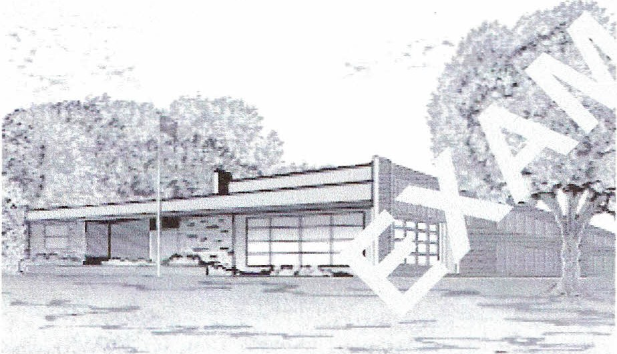Turf will be mowed at least weekly when actively growing. During hot, dry summer periods, mowing frequency may be reduced. Mower blades will be kept sharp. Clippings remain in place and decompose in the turf. Never will more than one­ third of the grass height be removed at any one mowing.

.;.......,.-...

Irrigating
Irrigation is not usually required. It is acceptable to allow the grass to brown and become dormant during the summer. Foot traffic will not
be allowed on dormant grass.

Fertilizing
Soil will be tested every 3 years for pH, phosphorus, and potassium levels. Recommended materials will be applied as soon as practical. Apply 2 to 3 pounds of nitrogen per 1000 ft2 annually. Fine fescue lawns will receive 1 to 2 pounds of nitrogen per 1000 ft2 annually. Fertilizers with approximately 30-50% slowly available nitrogen and at least a 2:1 ratio of nitrogen to potassium will be used. No more than 1 lb. nitrogen per 1000 ft2 of a rapidly available
nitrogen source will be applied at any one time.
If a 100% slow release fertilizer is used, then the total application may be as high as 2 lb nitrogen per 1000 ft2.
Topdressing
This site will usually not require topdressing, although ruts or rodent holes will be promptly filled with soil.
Aerating
High traffic areas that become badly compacted will be aerated but no more than once a year.
Pest management
Chemical controls may be applied after nonchemical methods fail but only when pests reach action thresholds and only with the consent of the School IPM Committee. If children regularly gather at the site, chemical pesticides will not be u5ed. Organophosphate insecticides and restricted-use pesticides will not be used on this site.
The IPM Coordinator will plan a monitoring
and record keeping system to inspect the lawn every two weeks for weeds, diseases, and insect pests and to evaluate the effectiveness of cultural controls.
Weed management. Weeds will be controlled
by hand-pulling and frequent mowing. Herbicides will be used only as a last resort and never when children are present.
Disease management. A mixture of turf grass species will be planted, including at least three cultivars for each species to establish a wide range of disease tolerance.
Insect management. The action thresholds for
this site will be set quite a bit higher than athletic fields. Insecticides should rarely be required. If white grubs reach action thresholds, apply nematodes (Heterorhabditis bacteriophora or Steinernema glaseri) in August and increase irrigation. If the grubs persist, halofenozide or imidacloprid will be applied in late July of the following year.
Vertebrate management. Rodent burrows
will be filled with suitable soil and over seeded or sodded. If rats are present, bait boxes will be installed and serviced weekly. Moles will be managed with harpoon traps.

Adapted from Outdoor IPM for Maine Schools
Chapter 2 - Organizing the School IPM Program 15

