School IPM Tool Kit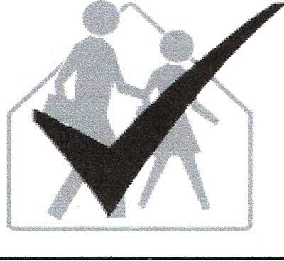 Administrators IPM Checklist

The checklist below outlines some basic steps required to start
your school's IPM Program.

Review state regulations applicable to school IPM, pesticides, and other chemicals.
Appoint a school employee as IPM coordinator to provide day-to-day oversight of the program.
Develop an official IPM policy.
Establish an IPM Advisory Committee to provide guidance; seek input from staff, students, and the community; and regularly review and provide input for revisions of the written IPM plan as necessary.
Conduct a thorough inspection of school buildings and grounds to assess needs for building and grounds pest prevention maintenance and sanitation, pest monitoring, and pest management needs (see Annual Inspection Checklist).
Identify key IPM team members, assign responsibilities, and establish protocols for timely and effective communication between administration, staff, and contracted service providers (if any) in the written IPM plan.
Develop a written IPM plan that establishes protocols for pest prevention, pest monitoring, IPM implementation, record-keeping, and evaluation. Include specific goals, timelines, and responsibilities.
Distribute IPM Action Packets to appropriate staff.
Provide adequate staff training.
Provide regular IPM and hazardous substances training opportunities for the staff.
Verify that staff members who apply pesticides are trained and certified applicators.
Encourage teachers to incorporate school pest control and IPM information into curricula and class projects.
Budget for timely building and grounds maintenance, pest prevention and pest management needs.
Regularly evaluate all aspects of the IPM program; modify as needed.
Find ways for students to participate in the school's IPM program, if nothing more than to regularly clean leftover food from their lockers and pick up trash.
Establish written requirements, including bid specifications, for contractors who apply pesticides.

