School IPM Tool Kit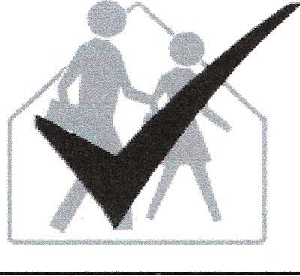
IPM Advisory Committee Checklist

Use this checklist to provide guidance for advisory committee responsibilities. Check those items for which the committee will be responsible and modify, or add other responsibilities.

Review the schools' IPM policy, or if necessary, work with administration to develop the policy.
Provide guidance in interpreting the IPM policy.
Assist IPM coordinator in exploring possible alternative pest management practices and products.
Provide leadership, guidance, or input for development of the written IPM plan. The IPM plan should describe specific implementation goals, timelines, and responsibilities for pest monitoring, pest prevention, and non-chemical and least-hazardous pest management methods.
Establish procedures for notifying parents and staff prior to pesticide applications.
Establish procedures for posting pesticide-treated areas.
Establish protocols and facilitate communication among program participants.
Annually review the written IPM plan and the operational IPM program to evaluate their effectiveness in meeting the schools' objectives. Identify weaknesses in the plan and operational program. Provide leadership, guidance, or input for revising the IPM plan and operational program as needed.
Work with administration to assist in annual review of staff training time tables to ensure that staff members receive appropriate training.
Provide guidance for actively engaging students in learning about IPM or contributing to the IPM program as a service-learning project.

