Introduction to the Environmental Management System Mode

What is an Environmental Management System (EMS)? An EMS is a system that uses comprehensive, systematic, planned and documented management processes and procedures that allow a school district to identify, analyze, control and reduce the impact of its activities and services on human health and the environment. An EMS provides a systems approach based on the Deming model of “plan, do, check and act”

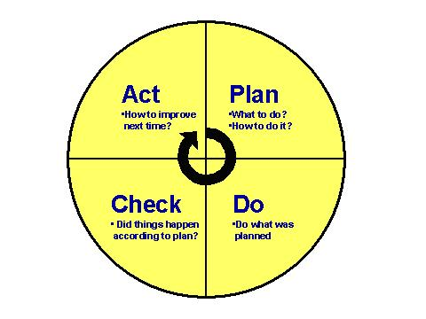.
The model provided in this IPM module is based on the EMS standard developed by the International Organization for Standardization (ISO) for the ISO 14001 Standard. Established in 1996, this framework is the official international standard and the most commonly used framework for an EMS. The model was used for industry and businesses.
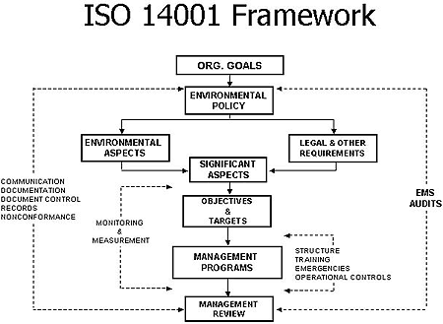

In 2006, as part of a national effort by EPA and a statewide effort by MassDEP, Lynn Rose worked with Madeline Snow of the University of Massachusetts Lowell, PEER Center to adapt this model for use by schools and municipalities in Massachusetts. We are using this modified version to guide the design of this IPM Module.
What are the Three Key EMS Commitments?
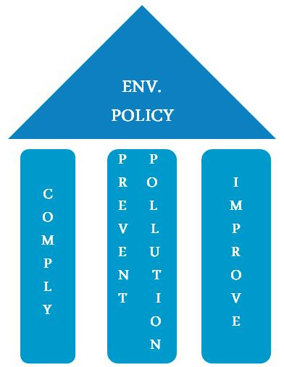

What are the basic activities involved in developing and implementing the framework of an EMS?
- analyzing the environmental impacts of a facility’s operations;
- identifying environmental legal and compliance requirements of the facility’s processes, and benchmarking the status of the facility’s compliance;
- setting environmental objectives and targets to reduce environmental impacts and comply with legal and compliance requirements;
- identifying roles and responsibilities to ensure employees’ awareness and competence and integration into all aspects of operations;
- establishing environmental management plans and a training program to meet these objectives and targets;
- monitoring and measuring progress in achieving the objectives and targets;
- auditing progress of the EMS and making improvements.

This framework helps a school achieve its environmental goals through consistent control of its operations. It addresses immediate and long-term impacts of its services and processes on the environment

How can we use the EMS framework to address IPM in our schools?

The EMS process guides participants to develop Environmental Management Plans (EMP) for each of the environmental media it has to address. Thus, this Integrated Pest Management (IPM) module can fit into the framework of an existing EMS or be used as a stand alone management plan.
What are the main phases of an EMS that have been utilized in this module?
1. Commitment and Policy
Administration commits to environmental improvement and establishes an environmental policy which is the foundation of the EMS. Each environmental management plan (see below) also has a policy (e.g. IPM Policy) which guides the activities in the plan.
2. Planning – Developing Environmental Management Plans (EMP)
The school identifies a stakeholder group, develops a policy, benchmarks the school district’s compliance and related issues, and identifies objectives and targets to address. An objective is an environmental goal (e.g., minimize use of pesticides). A target is a detailed, quantified requirement that arises from the objectives (e.g., reduce use of pesticides by 25% by September 2014).
The final part of the planning stage is developing an action plan called an EMP (e.g. IPM Environmental Management Plan), for meeting the objectives and targets. This involves designating responsibilities, establishing a schedule, and outlining clearly defined steps to meet the targets.
3. Implementation
The EMP is implemented using the necessary resources (human, financial, etc.). It involves:
- employee training and awareness
- operational controls (e.g. standard operating procedures, vendor contracts, etc.) to plan and manage your operations and activities in line with your policy, objectives and targets
- emergency preparedness and response for identifying potential emergencies, and developing procedures for preventing and responding to them.
- documentation of activities and data
- recordkeeping
- internal and external lines of communication.
4. Monitoring and Evaluation
This involves monitoring key activities and tracking performance to determine if specific targets are being met.
For an IPM Environmental Management Plan, this can involve assessment of both the IPM Plan and the conditions related to pest management in the building, for example:
- An annual building inspection to determine if the IPM plan is being followed, and to identify structural, sanitary and behavioral problems that need to be addressed.
- An annual review of the IPM Plan, IPM contractor services and service reports etc. to determine if the IPM strategy is being implemented as planned and what the outcome of that strategy is. Are pests being reduced? Are identified necessary building improvements being remediated? Are staff members following policy and work practices? Is the IPM contractor complying with the contract and any involved regulations?
5. Periodic Audit and Review
Administrators review the results of monitoring and evaluation data to see if the EMS is working and to determine whether the original environmental policy is meeting the goal. Aspects of the program or systems are then revised to optimize the effectiveness of the EMS. The review stage creates a loop of continuous improvement for a school.
6. Corrective and Preventative Action
Through the use of data from inspections, monitoring, and periodic EMS audit and review; you identify and correct problems, and prevent their recurrence. The goal is to ensure your EMS and EMPs are operating as intended, and that there is continual improvement.
What are the benefits of an EMS? An EMS provides tools to help manage your organization's environmental impacts efficiently and effectively and to improve environmental stewardship across the entire organization. Organizations who have implemented an EMS have realized the following benefits:
- cost savings;
- reduced risk;
- increased operational efficiency;
- positive external relations and public image;
- improved communication;
- greater employee stewardship;
- shared environmental solutions.
Resources
- US Environmental Protection Agency - http://www.epa.gov/ems/
- Massachusetts Department of Environmental Protection –
http://www.mass.gov/dep/about/priorities/overview.htm
- Wikipedia - http://www.epa.gov/ems/
- Environmental Management Systems: An Implementation Guide for Small and Medium Sized Organizations (PDF)

The PEER Center at UMass is one of several centers across the country funded by the U.S. EPA to assist the implementation of EMSs.

