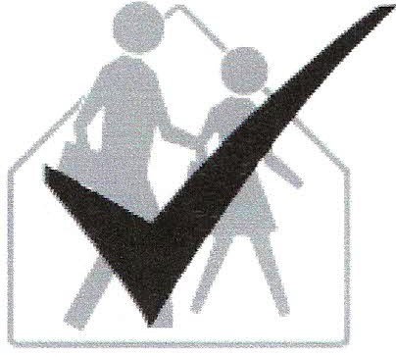 School IPM Tool Kit
IPM Coordinators Checklist

0 Review your schools’ IPM policy. If none has been adopted, work with your administration and school board to adopt an IPM policy. If your state has legislation requiring the use of an IPM plan, notification of parents and staff and or other regulations these should be included in your policy.
0 Follow the notification schedule required by regulation or your IPM Plan.
0 · Post application notices at the points of access.
0 Keep an IPM logbook that includes the IPM policy, IPM plan, copies of pesticide product labels, pest monitoring/sighting records, material safety data sheets (MSDS), and actions taken to manage pests and prevent re-infestation. An IPM logbook should be placed in each school in order to keep all required pest monitoring and application information together in a central location.
0 Ensure that pesticides are only applied in compliance with the school’s IPM policy and state regulations.
0 Ensure that pesticide applications and re-entry intervals do not conflict with school or community activities.
0 Review the written IPM plan or work with administrators to develop one. The written IPM plan should describe procedures for monitoring, preventing, managing, and reporting pests and pesticide use.
0 Keep current on alternative pest management products and practices.
0 Assign responsibilities identified in the IPM policy and plan (with support from appropriate administration and/or the IPM advisory committee) to school staff and any contracted service providers.
0 Work with administrators and the IPM advisory committee to review and revise, if necessary, contracts for pest management services to ensure services are provided within the framework of the IPM plan and policy.
0 Prepare and distribute IPM Action Packets to appropriate staff and apply the strategies proposed in the IPM plan.
0 Coordinate and approve all pest monitoring, prevention and management activities including the method, materials, timing, and location of any pesticide applications.

0 Ensure that contractors, staff, and students receive timely and accurate communication about pests, pest management actions, and record keeping.
0 Ensure that staff and students receive appropriate training and/or instruction needed to implement IPM.
0 Ensure that staff and students receive appropriate training and/or instruction needed to implement IPM.
0 Thoroughly inspect school buildings and grounds at least annually to determine the nature and extent of pest problems and contributing factors.
0 Maintain a prioritized list of structural and landscape improvements needed for pest prevention and management and ensure that necessary work is completed in a timely manner.
0 Prepare for emergency response to pest threats or pesticide hazards.
0 Evaluate all aspects of the IPM program annually to determine if management objectives are being met. Work with the IPM advisory committee to modify as appropriate.
0 Implement an indoor air quality (IAQ) prevention and monitoring program. Obtain free Tools for Schools IAQ kits at http://epa.gov/iaq/schools/index.html or 1-800-438-4318 (ask for EPA document # 402-K-95-001).

