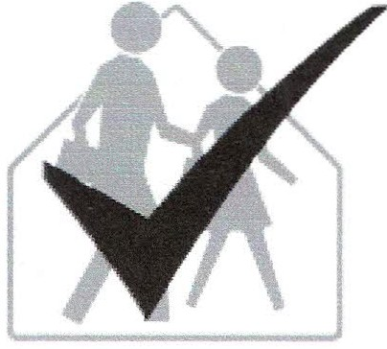
School IPM Tool Kit
School Nurse/Health Coordinator Checklist

Instructions
Name: 1. Read the information on this sheet.
Room/Area: 2. Check the appropriate "Yes" or "No" boxes. School: 3. Write any items needing attention (usually
Date Completed: indicated by a 'No' response) in the places at
the end of each section.
Signature: 4. Return completed checklist to the IPM
coordinator; keep a copy for your records.
It has been well documented that pests and pesticides contribute to asthma and other health problems.
It is the policy of this school district to manage pest problems in a way that poses the least hazard to human
health and the environment. To this end, we have adopted an integrated pest management (IPM) program.
IPM combines pest prevention, non-chemical pest control methods, and the appropriate use of pesticides
that are the least harmful to human health and the environment. By addressing and correcting the root
causes of pest problems, IPM can provide long-term, economical pest control and minimize the risk of
pesticide exposure.
We are asking for your cooperation with our IPM program. The success of IPM depends on the
involvement of many individuals. Students, teachers, school staff, administration, and parents are all
participants in the IPM program. Together we can help reduce pest problems and pesticide applications.
You can have a positive impact on our goal to reduce pest problems by completing the following checklist.

as indicated by your IPM coordinator.
Yes No
0 0 School health professional is a member of the school's environmental, safety, IPM,
and indoor air quality teams.
0 0 School health professional maintains MSD sheets for all pesticides used on school
property.
0 0 The school health professional is aware of the connection among allergies, air
quality, pests, and pesticides.
0 0 School health professional is trained to identify the signs and symptoms of pesticide
exposure.
0 0 The school health professional communicates with administration, teachers,
custodians, and contractors to minimize risk of unhealthful chemical exposure to
school staff and students.
0 0 Records of all children and staff members with asthma or chemical sensitivities are
maintained.
0 0 A log of health complaints that notes symptoms, location and time of symptom
onset and exposure to pollutant sources is maintained.
0 0 The school health professional is alert to potential trends in health complaints,
especially in timing or location of complaints.

Yes No
0 0 Policies/procedures addressing animals in the classroom are in place.
The best way to keep the school free of animal allergens is to keep animals out of
school.

0 0 School health professional communicates accurate head lice information to
parents, students, and school staff.

0 0 School health professional knows effective, alternative head lice treatments and
where to get more information.

0 0 School health professional emphasizes to parents the importance of reading and
following the instructions on lice-control shampoos if a parent chooses to use
these products.

0 0 School health professional can explain the limitations and actual effects of over-
the-counter and prescription treatments on head lice at their different life stages.

0 0 Policies/procedures addressing the use of insect repellents are in place.

Action needed: Completed (Date/Initials)

