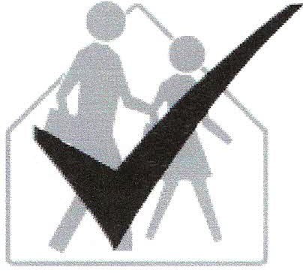School IPM Tool Kit
Turf Managers Checklist
Name: Instructions
Room/Area: 1. Read the information on this sheet.
School: 2. Check the appropriate "Yes" or "No" boxes.
Date Completed: 3. Write any items needing attention (usually indicated by a 'No' response) in the places at the end of each section.
Signature: 4. Return completed checklist to IPM Coordinator. Keep copy for your records.
It is the policy of this school district to manage pest problems in a way that poses the least hazard to human health and the environment. To this end, we have adopted an integrated pest management (IPM) program. IPM combines pest prevention, non-chemical control methods, and the appropriate use of pesticides. IPM addresses and corrects the root causes of pest problems to provide long-term, economical pest control with a minimum risk of pesticide exposure.
We are asking for your cooperation with our IPM Program! The success of IPM involves many individuals. Students, teachers, school staff, administration, and parents all participate in IPM.
Together we can help reduce pest problems and pesticide applications. You can help our goal to reduce pest problems by completing the following checklist as indicated by you IPM coordinator.

Turf Management
Yes No
0 0 Turf is regularly scouted for weeds, insects, and diseases.
0 0 Monitoring records are kept in the IPM logbook.
0 0 Pests are identified before any control actions are taken.
0 0 Control actions are recorded in the IPM logbook.
0 0 Turf receives 1 inch of water as rain or irrigation per week, or is not used and is allowed to go dormant during summer months.
Yes No
0 0 If irrigation is used, it is applied during early morning hours.
0 0 Turf is mowed when the grass is dry and soil is not excessively moist.
0 0 Mowing height is set to 2 1/2-3 inches.
0 0 Mowing is frequent enough to remove no more than 1/3rd of the leaf blade at any one cutting.
0 0 Mowing blades are kept sharp.
0 0 Soil is tested every year, pH is adjusted and fertilizer is added as indicated.
0 0 Low maintenance turf is soil tested every 3 years.
0 0 Turf is fertilized at least twice each year. Low maintenance turf is fertilized once a year.
0 0 High-use turf is aerified at least once each year.
0 0 Bare spots and damaged turf are over seeded and top-dressed as necessary.
0 0 Thatch is kept to no more than 3/4-inch depth.
Action needed: Completed (Date/Initials)

