I. Weed Identification

Working individually, or in pairs, identify as many of the flagged weeds as you can during the first 15 min. of this session. Note in the area provided any knowledge you have about the species.
Specimen | Plant family, life cycle, traits that contribute to the species’ success as a weed
1
2
3
4
5
6
7
8
9
10

II. Methods and Resources for Weed Identification

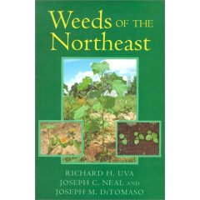
A. Print
Weeds of the Northeast by Uva, Neal and DiTomaso (1997, Cornell University Press; ISBN: 0-8014-8334-4) is an excellent regional guide.
The definitive guide is the Manual of Vascular Plants of Northeastern United States and Adjacent Canada, Second Edition, by Gleason and Cronquist (1991, New York Botanical Garden; ISBN: 0-89327-365-1), and the highly recommended Illustrated Companion to Gleason and Cronquist’s Manual by Holmgren (1998, New York Botanical Garden; ISBN: 0-89327-399-6).

B. On-line

1. Identification
There are relatively few sites that attempt to directly aid in the identification of an unknown specimen. On example, from the Illinois Council on Food and Agricultural Research (http://weedid.aces.uiuc.edu/index.html) allows the user to input information on the specimen and subsequently parses the database of 172 species, removing all records lacking the assigned attribute. Virginia Tech has developed a similar tool to assist in grass weed identification (http://whizlab.isis.vt.edu/servlet/wid). Note, that these tools can be misleading if the specimen you have is not included in the initial database.
2. Images
There are many photo-herbaria sites on line that can useful to confirm identification of a specimen, including, of course, http://plants.usda.gov/. A fine collection of images is also available from the UMass Extension Weed Herbarium (http://www.umassgreeninfo.org/fact_sheets/weed_herbarium/common_name_list.htm).
3. University of Maine Herbarium Catalog
If accurate identification is critical, but inconclusive based on comparison to images, the University of Maine Herbaria contains a large collection that can serve as voucher specimens (http://herbaria.umaine.edu/). The on-line catalog is also quite useful if putative identification is that of a rare or unusual species for the particular location. This database can tell you whether a species has ever been submitted to the herbaria from a particular area.

III. Weed Biology: Characteristics and Strategies

A. Introduction
>250,000 <200 90%

B. “Ideal Weed”

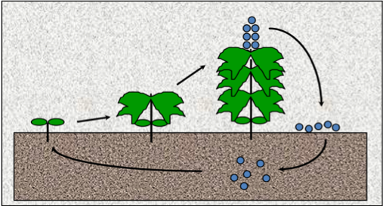
C. The Weed Seedbank

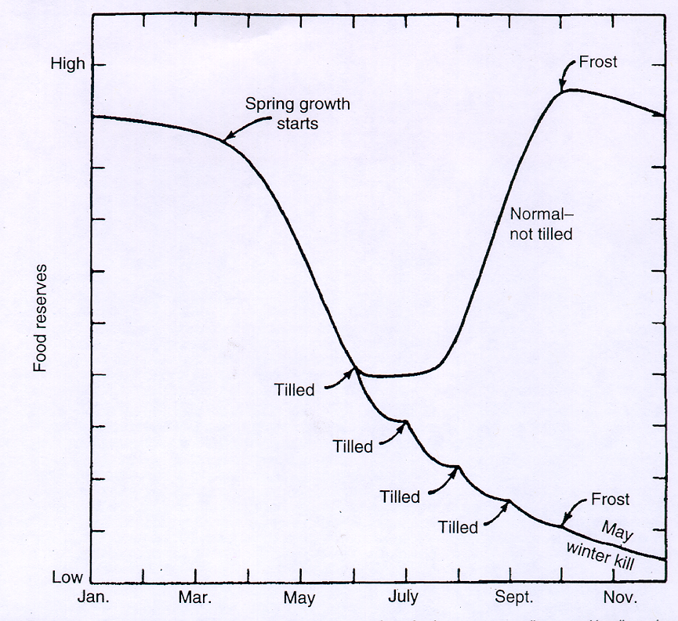

D. Carbohydrate Dynamics in Perennial Weeds

E. Spatial Considerations

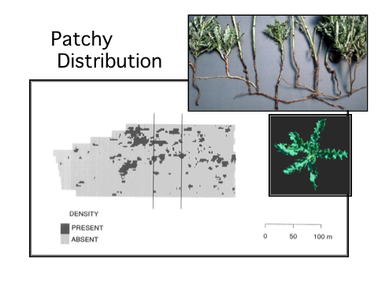
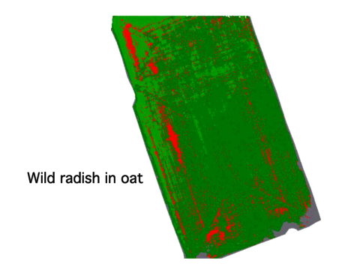
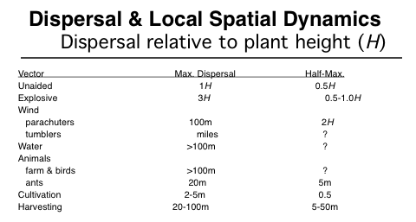

IV. Weed Management: Principles and Practices

A. Principles
1. Reduce density
2. Reduce damage done per surviving individual
B. Practices
1. Direct control tactics

2. Indirect control tactics

C. Many Little Hammers

Resources:
Ecological Management of Agricultural Weeds by Liebman, Mohler and Staver is an exceptionally well-referenced and comprehensive volume somewhat uniquely focused on ecologically-based weed management (2001, Cambridge University Press; ISBN: 0-521-56068-3).
Vegetable Farmers and Their Weed Control Machines is a video featuring innovations and equipment used on nine New England vegetable farms. It is available from the University of Vermont Center for Sustainable Agriculture (802-656-5459).
Practical Weed Control is a recently translated Dutch field manual detailing the latest European and North American innovations in physical weed control, including detailed information on the strengths and limitations of various tools, and tips for optimal adjustment and use in the field. (2006, Wageningen Applied Plant Research; ISBN: 90-77861-04-1

